Frequently Asked Questions

- Where is the department located?
The Neurophysiology department is located on the third floor of the Outpatients building in the “King Unit”.
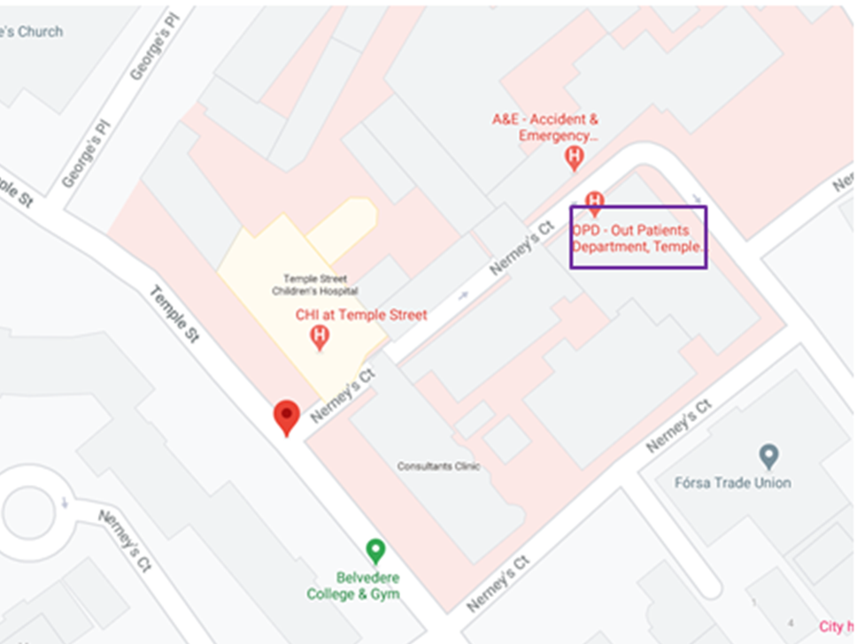
- Is fasting required prior to the test?

No, your child can eat and drink as normal. However, we would ask that you refrain from giving them anything with caffeine or high sugar content close to the test.

- Is medication given to help my child sleep?

No, we do not use sedatives routinely in the department. If your child uses medication to help them sleep at home, please contact the department.

- How much sleep can my child have the night before the test?

Sleep deprivation guidelines are available on the website. Every child is different and some guidelines may need to be changed slightly. The child is required to sleep for 20-30 minutes during a sleep deprived test. Children over 2 years of age should always be awake at least 6 hours before their EEG.

- How long will the EEG take?

The appointment lasts 45-60 minutes for a routine EEG and 60-90 minutes for a sleep deprived EEG. The department has an appointments only system so delays are uncommon.

- Who can accompany my child?

One parent may accompany their child for the entirety of the test. We cannot admit a second adult or any siblings into the waiting room.

- What if I feel my child cannot cooperate with the test?

If your child has sensory issues, Autism or conditions which prevent them from sitting for extended periods of time and typically find experiences such as brushing /washing/cutting their hair very traumatic, please contact the department directly.

- What happens if my child does not sleep during their sleep EEG?

Sleep deprivation is the most important part of the preparation for this study. This is so the brain is put under stress which increases the yield of the test. If your child is sleep deprived appropriately but does not sleep there may still be enough data for the consultant to interpret; alternatively the test may need to be repeated.

- Is my child likely to have a seizure after the test?

We recommend closely monitoring your child for 24 hours after sleep deprivation and allowing them to sleep as much as they need to as sleep deprivation can trigger a seizure in children who are sensitive to their sleep hygiene.

- What if they have a seizure before the test?

If your child has a seizure while sleep depriving treat is as any other seizure by either managing at home or calling an ambulance. If they sleep after, try to wake them and bring them to their appointment if you feel they are able.

