Your child has been prescribed Prednisolone
Do not stop giving prednisolone, as your child’s transplanted organ may be rejected and they may become seriously ill.
What is prednisolone available as?
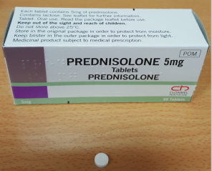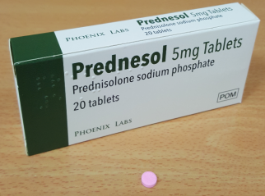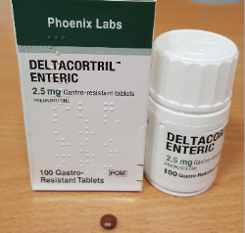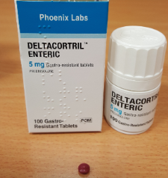
Enteric-coated tablets: 2.5 mg, 5 mg; these contain lactose (Brand names: Deltacortril®)
Dispersible tablets:
5mg, Prednesol®
Tablets: 1 mg, 5 mg, 25 mg; these contain lactose

Prednisolone belongs to a group of medicines called corticosteroids (or steroids).
When should I give prednisolone?
Prednisolone is usually given once in the morning. Try to give this medicine at about the same time each day so that it becomes part of your routine. You may find it helpful to use an alarm clock or the reminder on your mobile phone to remind you.
How much should I give?
Your doctor will work out the amount of prednisolone (the dose) that is right for your child. The dose will change frequently in the early days of treatment when your child is likely to be on multiple prednisolone tablets per day. It is important that you follow your doctor’s instructions about how much to give and make note of dose changes in your medication passport. Your doctor will prescribe gradually smaller doses and/or tell you to give the medicine on alternate days
How should I give it?
Tablets should be swallowed with a glass of water, milk or juice. Your child should not chew the tablet. You can crush the tablet and mix it with a small amount of soft food such as yogurt, jam or mashed potato. Make sure your child swallows it straight away without chewing. Do not crush enteric-coated tablets. These have a coating to protect the stomach and need to be swallowed whole.
Dispersible tablets: Dissolve the tablet(s) in water or fruit juice. Your doctor or pharmacist will have told you how much liquid to use, and how much to give to your child. Make sure your child drinks it all straight away, using a medicine spoon or oral syringe. Alternatively, these can be swallowed as normal tablets. The solution is very bitter and a strong tasting juice mixed with the solution or ready to take straight after may help.

When should the medicine start working?
The medicine starts to work as soon as your child starts taking it. You will not see any difference in your child. However, they must continue to take it as your doctor has told you to, otherwise the transplanted kidney may be rejected by the body.
What if my child is sick (vomits)?
If your child is sick less than 30 minutes after having a dose of prednisolone, give them the same dose again. If your child is sick more than 30 minutes after having a dose of prednisolone, you do not need to give them another dose. Wait until the next normal dose. If your child is sick again, seek advice from the renal unit. They will decide what to do and advise you accordingly.
What if I forget to give it?
Give the missed dose when you remember during the day, as long as this is at least 12 hours before the next dose is due. Never give a double dose of prednisolone.
What if I give too much?
It can be dangerous to give too much prednisolone. If you think you may have given your child too much prednisolone, contact your doctor or take your child to hospital.
Take the medicine container or packaging with you, even if it is empty. This will be useful to the doctor. Have the packaging with you if you telephone for advice.
Are there any possible side-effects?
We use medicines to make our children better, but sometimes they have other effects that we don’t want (side-effects).
Side-effects you must do something about:
Prednisolone can cause ulcers in the stomach. Tell your doctor straight away if your child has bad stomach pain or repeated vomiting (being sick).
If your child develops a rash or severe/unexplained bruising, contact your doctor straight away, as there may be a problem with your child’s blood.
If your child has eye pain or changes in their vision, contact your doctor straight away.
Other side-effects you need to know about:
•Your child may have stomach ache, feel sick (nausea) or be sick (vomit) or may have indigestion (heartburn). Giving the medicine with some food may help.
•Your child may have an increased appetite and gain weight while taking prednisolone. You can help by making sure your child has plenty of physical activity, and by offering fruit and vegetables and low-calorie food, rather than food that is high in calories (e.g. cakes, biscuits, sweets, crisps).
•Your child may have trouble sleeping and nightmares and may feel depressed, or their behaviour may change in other ways. Contact your doctor for advice if you are concerned.
•All steroid medicines, including prednisolone, may affect the adrenal glands so that they produce less of a hormone called cortisol when the body is stressed (e.g. during illness or injury). This means that your child may have more difficulty fighting off an infection, or may recover less quickly from injury or after surgery.
Side-effects with high doses or long courses
•Prednisolone can slow growth and affect puberty. It can also cause growth of body hair and irregular periods in girls. Your doctor will check your child’s growth and development. If you have any concerns, talk to your doctor.
•Your child may be more at risk of severe infections. They should stay away from anyone with an infection (such as chicken pox, shingles, measles) if they have not had these illnesses or have not been vaccinated. Contact your doctor for advice if they have been in contact with someone who has an infection, as they may need preventative treatment
•If your child is unwell and you are worried about an infection, contact your doctor straight away.
•Your child’s skin may become thinner, and heal more slowly than usual. Acne (spots) may become worse or your child may develop mouth ulcers or thrush (candidiasis). If you are concerned, contact your doctor.
•Your child may develop problems with their hip bones or their bones may become weaker (osteoporosis). The muscles around the hips and shoulders may also become weaker. If your child has any difficulty walking or moving around, contact your doctor.
•Occasionally, prednisolone causes diabetes. If your child seems more thirsty than normal, needs to pass urine (wee) often, or starts wetting the bed at night, contact your doctor.
There may, sometimes, be other side-effects that are not listed above. If you notice anything unusual and are concerned, contact your doctor. You can report any suspected side-effects to a UK safety scheme at http://yellowcard.mhra.gov.uk.
Can other medicines be given at the same time?
•You can give your child medicines that contain paracetamol, unless your doctor has told you not to.
•You should avoid giving your child medicines that contain ibuprofen.
It is important to tell your GP and pharmacist that your child is taking prednisolone and check before giving any other medicines. This includes herbal or complementary medicines.

Is there anything else I need to know about prednisolone?
In a very few cases, children become very unwell when they stop or reduce the amount of any steroid medicine they are taking, including prednisolone. If you are at all worried about this, contact your doctor.
The use of steroids in children receives a lot of bad press. However, use of prednisolone in transplant recipients provides a lot of benefit, and is unlikely to cause any long-term harm as long as you use the medicine as your doctor has told you to. If you are at all worried, talk to your doctor or pharmacist.
Your child should not usually stop taking prednisolone suddenly because they will get withdrawal symptoms: they will feel unwell, dizzy and thirsty and may be sick (vomit). Your doctor will give you more advice.
•Your child usually cannot have live vaccines while on prednisolone. If your child is due to have an immunisation (vaccination), tell the nurse or doctor that they are taking prednisolone.
•Make sure that you always have enough medicine. Order a new prescription at least 2 weeks before you will run out.
•Make sure that the medicine you have at home has not reached the ‘best before’ or ‘use by’ date on the packaging. Give old medicines to your community pharmacist to dispose of.
Where should I keep this medicine?
•Keep the medicine in a cupboard, away from heat and direct sunlight.
•Keep the medicine in the container it came in.
•Make sure that children cannot see or reach the medicine.
Who to contact for more information?
Your child’s doctor, pharmacist or nurse will be able to give you more information about prednisolone and about other medicines used to prevent transplant rejection.
Temple street main Hospital PH: (01) 8784200. Renal clinic PH: (01) 8784257. St. Michaels C ward PH: (01) 878 4258 Renal Pharmacist available through switch on bleep 105.

