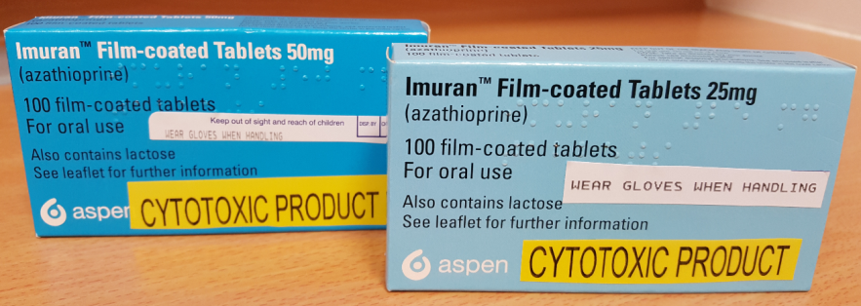
SAFETY ALERT
There are two different strengths of Imuran® with similar packaging
25mg and 50mg
Please take the time to familiarise yourself with the different tablets and take extreme care not to confuse the different strengths when administering a dose.

Your child has been prescribed Azathioprine
Brand names: Imuran®, (another less common brand is Azamune®)
Why is it important for my child to take this medicine?
Azathioprine belongs to a group of medicines called immunosuppressants. It works by helping to stop your child’s immune system from attacking (rejecting) their transplanted kidney. This will allow the new kidney to work normally.
What is azathioprine available as?
•Tablets: 25 mg (orange), 50 mg (yellow); Imuran tablets contain lactose
•Liquid medicine can be ordered specially from your pharmacist; this may contain a small amount of lactose
When should I give azathioprine?
Azathioprine may be given once or twice each day. Your doctor will tell you how often to give it.
•Once a day: this is usually in the morning OR the evening.
•Twice a day: this should be once in the morning and once in the evening. Ideally, these times are 10–12 hours apart, for example some time between 7 and 8 am, and between 7 and 8 pm.
Give the medicine at about the same time(s) each day so that this becomes part of your child’s daily routine, which will help you to remember.
How much should I give?
Your doctor will work out the amount of azathioprine (the dose) that is right for your child. The dose will be shown on the medicine label. It is important that you follow your doctor’s instructions about how much to give and make note of any dose changes in your medication passport.
How should I give it?
Give azathioprine after your child has eaten and with a glass of water.
Tablets:
Tablets should be swallowed with a glass of water, milk or juice. Your child should not chew the tablet.
You can crush the tablet and mix it with a small amount of soft food such as yogurt, honey or jam. Make sure your child swallows it straight away, without chewing. Wash your hands and all equipment used thoroughly afterwards to make sure that no-one else takes any of the medicine.
Liquid medicine:
Measure out the right amount using an oral syringe or medicine spoon. You can get these from your pharmacist. Do not use a kitchen teaspoon as it will not give the right amount.
When should the medicine start working?
The medicine will start working after a few hours, although you will not see any difference in your child.
What if my child is sick (vomits)?
•If your child is sick less than 30 minutes after having a dose of azathioprine, give them the same dose again.
•If your child is sick more than 30 minutes after having a dose of azathioprine, you do not need to give them another dose. Wait until the next normal dose.
What if I forget to give it?
•If you usually give it once a day: Give the missed dose when you remember during the day. You do not need to wake up a sleeping child to give a missed dose. You can give the missed dose in the morning. Only give the missed dose at least 12 hours before the next dose is due.
•If you usually give it twice a day: If you remember up to 4 hours after you should have given a dose, give your child the missed dose. For example, if you usually give a dose at about 7 am, you can give the missed dose at any time up to 11 am. If you remember after that time, do not give the missed dose. Just give the next dose as usual.
Never give a double dose of azathioprine.
What if I give too much?
It may be dangerous to give too much azathioprine.
If you think you may have given your child too much azathioprine, contact your doctor or take your child to hospital. Take the medicine container or packaging with you, even if it is empty. This will be useful to the doctor. Have the medicine packet with you if you telephone for advice.
Are there any possible side-effects?
We use medicines to make our children better, but sometimes they have other effects that we don’t want (side-effects).
Side-effects you must do something about
If your child gets flu-like symptoms, sore throat, or unusual bleeding or bruising, contact your doctor, as there may be a problem with your child’s blood.
If your child starts being sick every few hours, has stomach pains, is very sleepy or has jaundice (the skin or the whites of the eyes look yellow), take them to your doctor or hospital straight away as there may be a problem with your child’s liver.
Other side-effects you need to know about:
Your child may get these side-effects when they first start taking azathioprine. They will usually settle down within a week or so as your child’s body gets used to the medicine.
Continue to give azathioprine to your child as your doctor has told you to. Contact your doctor if the side-effects go on for longer than a week.
•Your child may feel sick (nausea) and have diarrhoea. It may help to give azathioprine with some food, or shortly afterwards.
•Your child may feel less hungry (lose their appetite). Encourage them to eat small meals often.
There may, sometimes, be other side-effects that are not listed above. If you are concerned, contact your doctor.
Can other medicines be given at the same time as azathioprine?
•You can give your child medicines that contain paracetamol or ibuprofen, unless your doctor has told you not to.
•Azathioprine should not be taken with some medicines that you get on prescription or from a pharmacy. Check with your doctor or pharmacist before giving any other medicines to your child. This includes herbal or complementary medicines.
Is there anything else I need to know about this medicine?
Your child will need to take this medicine all the time to stop rejection of their transplanted kidney. Do not stop giving them azathioprine without talking to your doctor first.
•Azathioprine affects your child’s immune system so they may get more infections such as chest infections, coughs and colds, and they may take longer than usual to fight these off. Try to keep your child away from people with serious infections if you can, although they can still go to school and nursery as usual.
If your child comes into contact with anyone who has chickenpox, shingles or measles, contact your doctor straight away, as they may need special preventative treatment.
•Your child will need regular blood tests to check whether azathioprine is affecting their blood or liver and to check their transplanted kidney is working. These tests will need to be done frequently for the first month that your child is taking azathioprine and then at least every 3 months. It is important that you take your child for these blood tests.
•Protect your child’s skin from strong sunlight by dressing them in long-sleeved tops and trousers and a hat, and using high-factor sunscreen (at least SPF 30). This is because there is a theoretical risk (but not proven) of your child getting some types of cancer, including skin cancer, when they take azathioprine for several years.
•If your child is due to have an immunisation (vaccination), tell the nurse or doctor that your child is taking azathioprine.
•Azathioprine may harm an unborn baby. If your daughter is sexually active, it is very important that she uses adequate contraception to prevent unplanned pregnancy. The oral contraceptive pill can be used safely in woman or girls taking azathioprine. If your daughter is worried that she may be pregnant, it is important that she sees your family doctor as early as possible. She should keep taking her medicine until she sees her doctor.
General advice about medicines
•Try to give medicines at about the same times each day, to help you remember.
•Make sure that you always have enough medicine. Order a new prescription at least 2 weeks before you will run out.
•Make sure that the medicine you have at home has not reached the ‘best before’ or ‘use by’ date on the packaging. Give old medicines to your pharmacist to dispose of.
Where should I keep this medicine?
•Keep the medicine in a cupboard away from heat and direct sunlight. It does not need to be kept in the fridge.
•Make sure that children cannot see or reach the medicine.
•Keep the medicine in the container it came in.
Who to contact for more information
Your doctor, pharmacist or nurse will be able to give you more information about azathioprine and about other medicines used to prevent transplant rejection.
Temple street main Hospital PH: (01) 8784200. Renal clinic PH: (01) 8784257. St. Michaels C ward PH: (01) 878 4258 Renal Pharmacist available through switch on bleep 105.

