blood transfusion ?

The alternatives available and how well they work will depend on your child’s condition.

Sometimes, medication may be used to help your child make their own blood or to prevent or control bleeding.

The alternatives available may not be a suitable option for your child. Your doctor will discuss the options available to you and will explain the reasons a blood transfusion is necessary.

Can I donate blood to my child ?

No. Parent’s blood may not be a suitable match for their child. There is no evidence that blood from relatives is safer than blood from voluntary donors.

What if I have other concerns?

If you have any concerns in relation to your child receiving a blood transfusion, please discuss with your doctor or nurse. An experienced haemovigilance officer can also be contacted to discuss them with you.

For information about becoming a blood donor please contact:

Irish Blood Transfusion Service Tel: 1850 73 11 37
Website: www.giveblood.ie

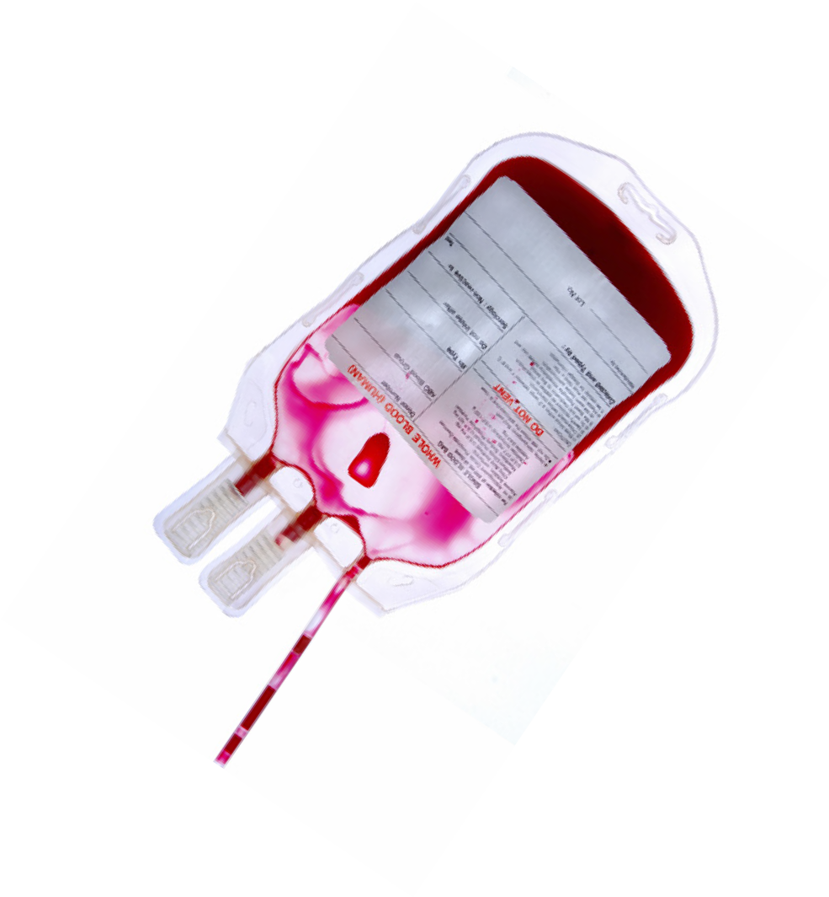

Acknowledgement to NHS Blood and Transplant: www. blood.co.uk/about- blood/information- for-patients

Haemovigilance Departments in Temple Street Children’s University Hospital, Our Lady’s Children’s Hospital Crumlin, The National Children’s Hospital Tallaght.

Version 3
Approval date; April 2018 Review date; April 2020

Information correct at time of print

Questions you may have about your child’s blood transfusion
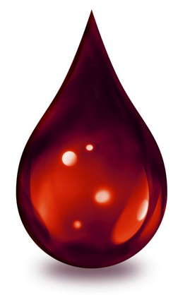
Information for Parents and
Guardians
A blood transfusion should only be given when really necessary. The decision to give your child a blood transfusion is made only after careful consideration by your child’s doctor in consultation with you.

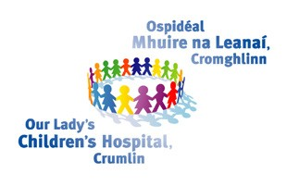
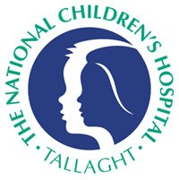

A blood transfusion is giving blood products such as red cells, plasma or platelets through a small tube into your child’s vein.

Red cells: carry oxygen around the body.
Plasma: straw coloured liquid, containing proteins that help blood to clot.
Platelets: straw coloured cells, help blood to clot.
Red Blood Cell
Plasma

Platelet
l

Blood Vesse

Why might my child need a blood transfusion?

Some reasons may include:
- To replace blood lost during surgery.
- Anaemia - shortage of red blood cells, resulting in the body not getting enough oxygen.
- Blood disorders.

transfusion ?

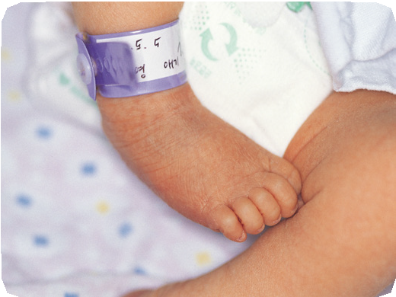
The risk that a blood transfusion will make your child unwell is very low. One of the most important ways of ensuring a safe transfusion is to make sure your child
receives the right blood. To ensure this happens
staff will check your
child’s identity on their ID band, both when they take blood samples and before the transfusion is given. If you are with your child, you may also be asked to confirm their full name and date of birth. Please remind the nurse or doctor to ask you this if they forget to do so.

The possibility of getting an infection from a blood transfusion is very low:
- All donors are voluntary and unpaid.
- Before giving blood, all donors are carefully tested must answer detailed questions about their general health and risk factors for disease.
Risk of getting a virus from blood transfusion in Ireland:
HIV:1 chance in 15 million Hepatitis C:1 chance in15.3million Hepatitis B:1 chance in 2.2 million

their blood transfusion ?

Most infants and children will feel no different during their blood transfusion, but some may develop a slight fever, chills or a rash. These are usually due to a mild reaction and are easily treated with medication or by giving the blood more slowly. Your child will be closely monitored throughout their transfusion to check for any signs of a reaction.
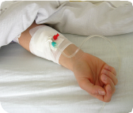
Severe transfusion reactions are extremely rare. If you have concerns about your child, during or any time after transfusion, inform your child’s nurse or doctor immediately.

If you know your child has had a previous transfusion reaction, or has special transfusion needs, inform your doctor or nurse immediately and ask them to let the Blood Transfusion Laboratory know. This information is particularly important if your child has received a blood transfusion in another hospital.

